SQL:DDL Statements, Indexing, and Views

1.Create a view titled “Products.” It should mirror your products table exactly.

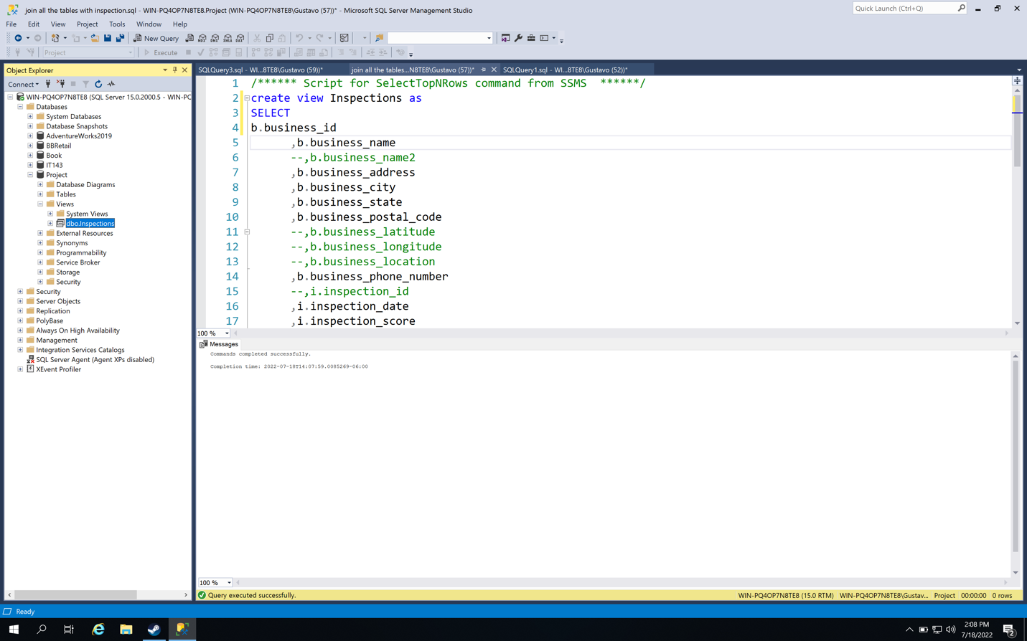

2.In your Project 3 table, create a unique clustered index on the natural key for the sales fact table.

INDEX GUI

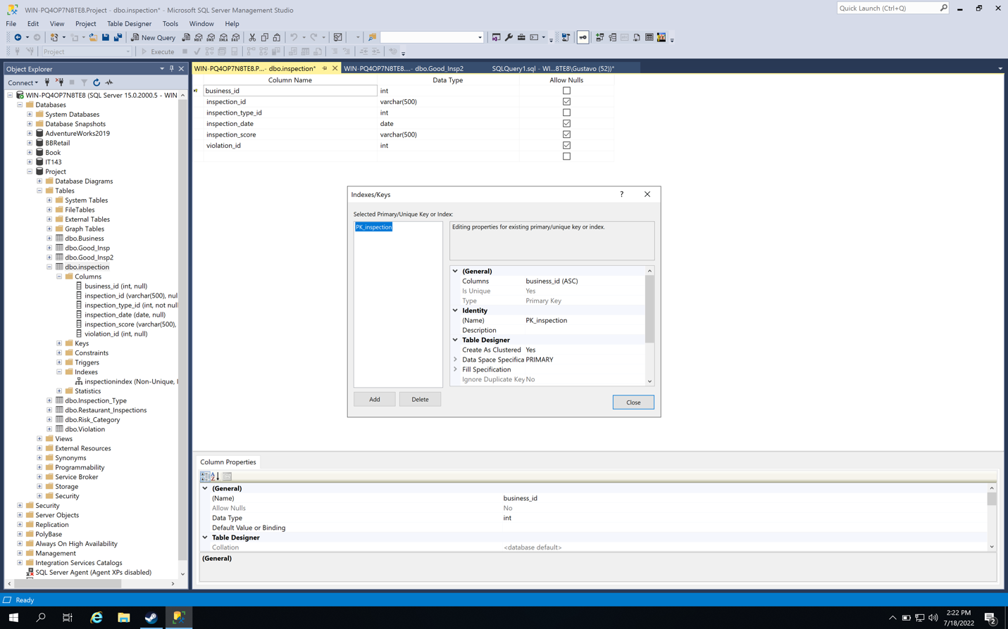

INDEX SCRIPT

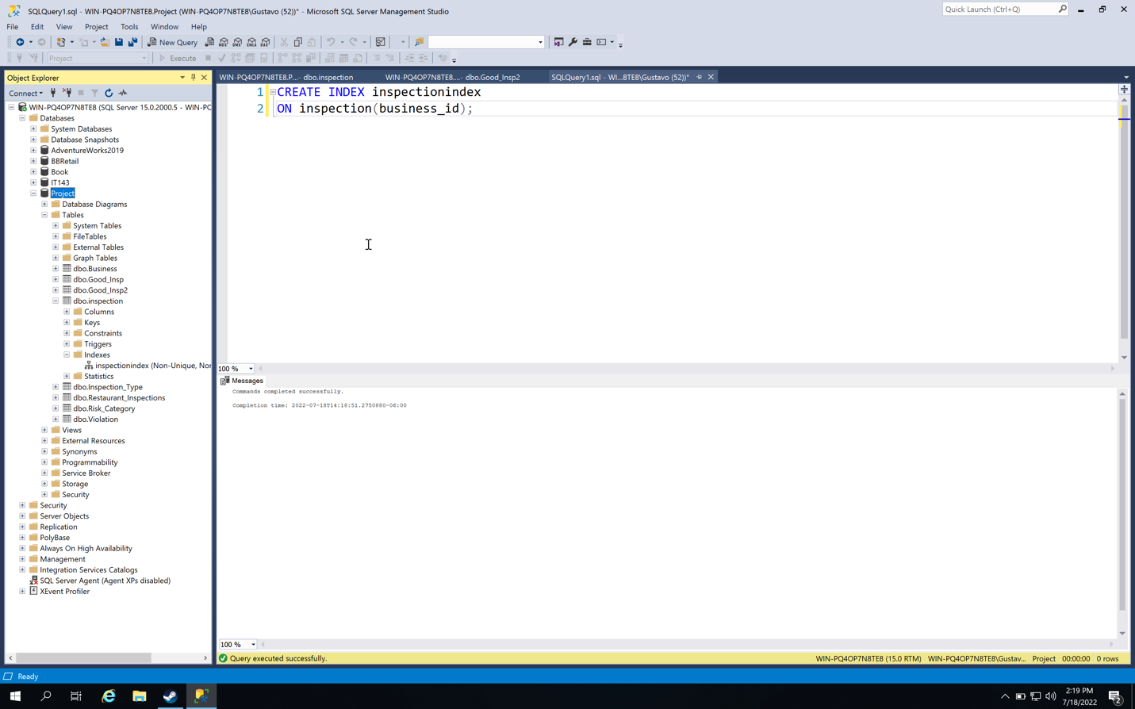

3.Drop the “ProductsOld” table.

